Project Proposal Document
Your project proposal is due Tuesday, May 5 at 10 AM and must include all of the following sections. A sample proposal document is available on Brightspace.
- Project description - What will you build?
  - A Randomized Generation of Horror Game
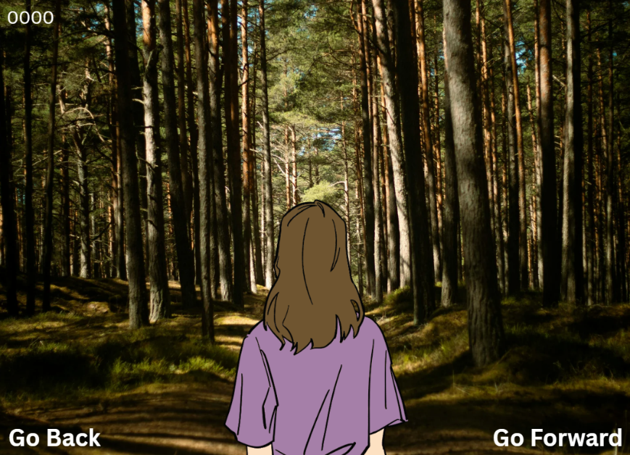
- UI mockup - What the user will see?

- What will the user do?
  - The user must survive until they have hit the required “random generated backgrounds limit”
- What are the inputs? What is the format?
  - Go Back
    - The user will go back to the previous background and creates a new background after clicking the “Go Forward” button
  - Go Forward
    - The user will go forward and create a new background alongside with specific events (clickable, hoverable, time, visually)
Including Winning the game.
- What are the outputs? What is the format?
  - Winning Message
  - Credits Message
  - Inspiration Message
  - Motivational Quotes
  - Reason for making the game
  - How I made the game
- Class design & UML diagram - What classes (programmer defined) will you make?
  - Sketch Plan (Class Design & UML Diagram)
- Timeline - What’s the plan?
  - Create Sketch plan of GUI
    - Scene 1
      - Layouts
    - Scene 2
      - Layouts
  - Code GUI
    - Create Visuals (Audio is last)
    - Animate Visuals
  - Code functionality (In a test file)
    - Creating Objects/Instances to relate with Event Handlers
  - Run the game
  - Polish the visuals, fix bugs, and add more (if I still have more ideas)

